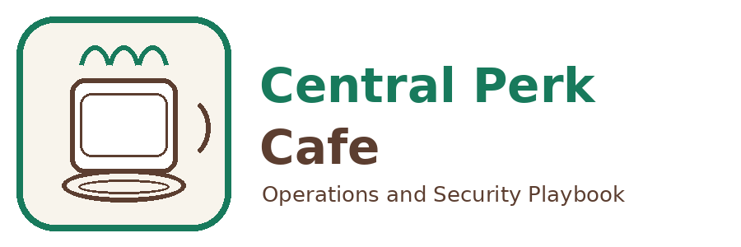 | Central Perk Cafe  123 Bean Street, Fort Collins, CO 80524  Phone: (970) 555-0112 | Email: ops@centralperk.example | Web: centralperk.example  Document: SOP-CS-002 | Version: 1.0 | Effective: 2026-01-15 | Owner: Operations Manager

Email Security and Phishing Response

Purpose
Reduce the likelihood and impact of phishing by hardening email controls and providing a simple, fast response process for staff. Focus on early reporting and rapid containment.

Scope
- Inbound email filtering and attachment controls
- Staff training and simulated phishing (optional)
- Reporting and response workflow for suspicious messages
- Business email compromise containment steps

Roles and Responsibilities
Store Manager | Ensures staff know how to report suspicious messages.
All Staff | Report suspicious email and avoid interacting with unknown links or attachments.
MSP Security Operations | Triage reported messages and run containment actions.
Operations Manager | Approves customer or vendor notifications if needed.

Frequency
- Filtering policies: reviewed quarterly
- Training: at hire and annually
- Phishing simulations: quarterly (optional)

Procedure
- Configure email authentication (SPF, DKIM, DMARC) for the business domain.
- Enable anti-phishing and anti-malware policies: link scanning, attachment sandboxing where available, and block high-risk file types.
- Tag external senders clearly and quarantine messages that fail authentication checks.
- Provide a one-click report method (add-in or forwarding address) for suspicious email.
- Upon report, MSP triages: determine if malicious, identify recipients, and remove related messages from mailboxes.
- If credentials may be compromised: force password reset, revoke sessions, check forwarding rules, and review recent sign-ins.
- If payment or vendor change request was acted on: initiate payment recall, contact vendor via known number, and document the incident.
- Capture incident notes and update training examples with sanitized screenshots.

Checklists
Staff Quick Actions
- Do not click links or open attachments
- Use the report button or forward to phishing@centralperk.example
- Call the manager if the message requests money, gift cards, or bank changes
- If you clicked, tell the manager immediately
MSP Containment
- Search and purge malicious message across mailboxes
- Reset impacted user credentials and revoke sessions
- Check mailbox rules, delegates, and OAuth app grants
- Review sign-in logs for suspicious IPs and impossible travel
- Document findings and remediation

Records and Evidence
- Email security policy settings export or screenshots
- Reported phishing tickets and outcomes
- Training completion logs
- Incident summaries for major events

MSP Value
- Tune filtering to reduce false positives while stopping common attacks.
- Provide fast triage and purge capability to remove malicious email at scale.
- Monitor sign-in risk and automate containment steps.
- Run targeted training and measure improvement over time.

Revision History
Version | Date | Author | Summary of Changes
1.0 | 2026-01-15 | Central Perk Ops | Initial release

